# ÔN TẬP UNIT 2 LỚP 5 (Ngày 18 tháng 10/2021)

**1 Look and read. Choose the correct word and write it on the line.**

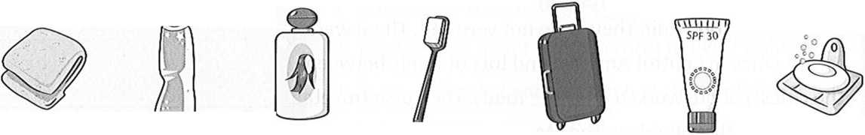

1. You use this to clean your teeth……… **a toothbrush………………**
2. This is usually white and in a tube. You use it to clean your teeth……………
3. You put this on your skin to stop it going red in the sun. ………..
4. You use this to dry your body……………………….

5 You use this to wash your hands or your body………………………

1. You use this to wash your hair. ………………………….
2. You put your things in this when you go on holiday.

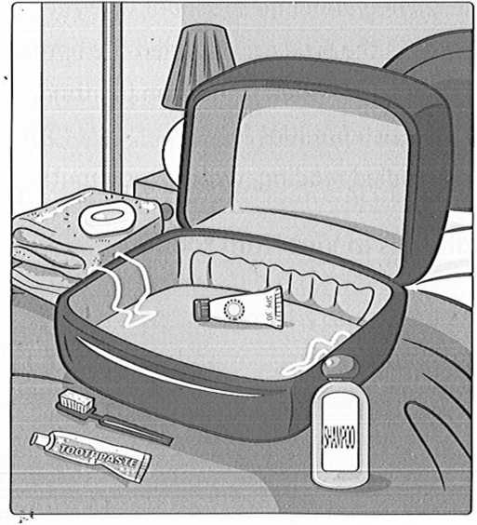**2.Write**

**Between:** ở giữa; **next to**: kế bên; behind: **phía sau;** **on the top**:ở trên đỉnh; **in front of** :ở đằng trước

|  |  |
| --- | --- |
| 1 | The ………………..is in the suitcase. |
| 2 | The suitcase is between the towel and the ……………………… |
| 3 | The………………… is next to the shampoo |
| 4 | The………………… is behind the toothpaste. |
| 5 | The ………………….is behind the toothpaste. |
| 6 | The………………………… is on the top of the towel. |
| 7 | The …………………. is in front of the toothbrush. |

**3.Look at the text , Where is Lan on holiday?**



**Review words:**

Snorkel(v) :lặn( bơi với một ống thở)

Amazing(adj): làm ngạc nhiên ,sửng sốt.

Seafood(n):hải sản

Restaurant(n):nhà hàng

Tonight : tối nay

Tomorrow: ngày mai

Show(v) : đưa ra, bày ra, chỉ ra

**4.Read again and write T( true) or F( false)**

1. Lan is in Nha Trang. …………………….
2. Lan is going to waterski this afternoon. ……………………
3. Lan’s family are going to eat seafood tonight. ……………………..
4. Lan is going to visit a museum tomorrow afternoon. ……………………..
5. Lan is going to buy Xuan a present. …………………….
6. Lan is going to come home tomorrow. ………………………

**5. Write a short answer**

|  |  |
| --- | --- |
| 1. Does Xuan live in HoChi Minh city |  |
| 1. Is the weather in Nha Trang sunny? |  |
| 1. Is Lan’s brother going to waterski? |  |
| 1. Does Lan like the food? |  |
| 1. Is she going to fly home tomorrow? |  |
| 1. Does she want to buy a camera from Nha Trang? |  |

**6.Read the text in the student book and write** :

|  |  |  |  |  |
| --- | --- | --- | --- | --- |
| tomorrow | tonight | *This afternoon* | soon | Next week |

|  |  |
| --- | --- |
| 1 | Lan is going to snorkel ………………………………………. |
| 2 | She is going to eat in a seafood restaurant …………………… |
| 3 | She is going to visit a museum ……………………………….. |
| 4 | She is going to fly home………………………………………. |
| 5 | She is going to see Xuan ………………………………………. |

1. **Read the text in the student book and fill in the correct circle .**

